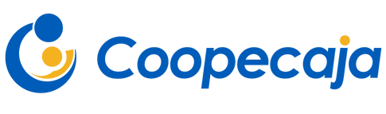
Who is Coopecaja?

COOPECAJA is currently an open financial institution that serves public and private sector workers in Costa Rica. It is one of the most solid entities in the national financial system, with more than 30,000 associates who have seen an improvement in their quality of life through its different products and services.

COOPECAJA was created with the basic premise of providing Costa Rican Social Security Fund workers with economic and social protection at reasonable costs. It was established as a cooperative entity on May 28, 1971, with the participation of its 28 founding members, who had the task of laying the groundwork and developing the social statutes of the organization. The cooperative was founded under the concept of a consumer cooperative, in which basic necessities, appliances, and other products were offered to associates at better prices and with payment facilities.

However, a few years later, the assembly had the vision to switch to the savings and credit model, which is still in place today. In the 1980s and 1990s, COOPECAJA solidified its position in the national financial system, and with the arrival of the new millennium, a new vision emerged that was materialized in 2005 when the general assembly made one of the organization's biggest and most successful decisions: to open up to the public sector, and in 2021, to the private sector, which has brought great benefits to the cooperative and the thousands of new associates who have enjoyed all the advantages that COOPECAJA offers since then.

Challenges and goals
To stimulate the potential of its collaborators with a view to continuous improvement and innovation of the entity's procedures and processes, COOPECAJA acquired the Laserfiche system in 2021. This system seeks to transform the organization's culture towards the digitization of its processes and procedures, as well as to centralize digital information for daily consultation and management. Since the implementation of this system, more than 170,000 documents totaling more than 1.7 million pages have been registered in the Document Manager, around 12 automated processes have been put into production, and 3 integrations with other tools and platforms. These processes include information loading flows from both back-office and front-office systems and integrations. This digital transformation counts on Laserfiche as the core to integrate all the information generated from other systems and from Laserfiche to compose a unique file for the associate that can be consulted not only by COOPECAJA employees but also in the future by the associates themselves.
Previously, the management and storage of the information generated by the business were mainly done with physical documentation stored in boxes outside their facilities, and the little that was digitized was stored in unsecured drives with no ability to search quickly.
As a service entity, David Bellido, COOPECAJA's project office manager, points out the need to open up new ways of managing different services and products towards its associates, always maintaining a digital focus.

Solution

The head of COOPECAJA's project office, David Bellido, explained that the company wants to automate all of the institution's procedures and processes. For this reason, they recently acquired several scanning equipment, starting the complete digitization of the documentation received and generated by these systems. Currently, 100% of the associates have their respective digital files, and their information is about 85% digitized. Additionally, they are awaiting electronic signature approval for the implementation of fully online requests.

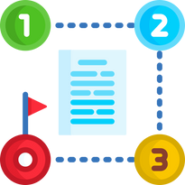

Benefits and results
The complete search and document consultation time have been optimized.

The complete load and indexing time of integrated systems has been optimized.

The automation of these processes has allowed the organization to know and control its procedures in real-time.

The document manager has allowed proper access and information security.

The implementation has benefited the organization by reducing paper usage and expenses, as their automated workflows generate 100% digital processes.

About

Aplicom was founded over 24 years ago with the aim of being a commercial ally in the digital transformation processes of companies. With 100% Costa Rican capital, their value proposition is to empower technology, innovation, and knowledge of organizations, reducing operational expenses and increasing efficiency and productivity in all their processes. In 1998, they decided to work with the renowned American system Laserfiche, with which they have successfully implemented various projects in different sectors and verticals, both in Costa Rica and throughout the region.

Aplicom's Differentiators

- 20 years of experience in Laserfiche implementation.
- 10 consecutive years as Laserfiche Winner Circle, an award given to the best representatives worldwide.
- A team of highly qualified and certified consultants directly by Laserfiche.
- Present in the region implementing projects with Laserfiche: Panama, Chile, Bolivia, Mexico, Puerto Rico, Dominican Republic, Haiti.

