Who is Constructora Volio & Trejos?
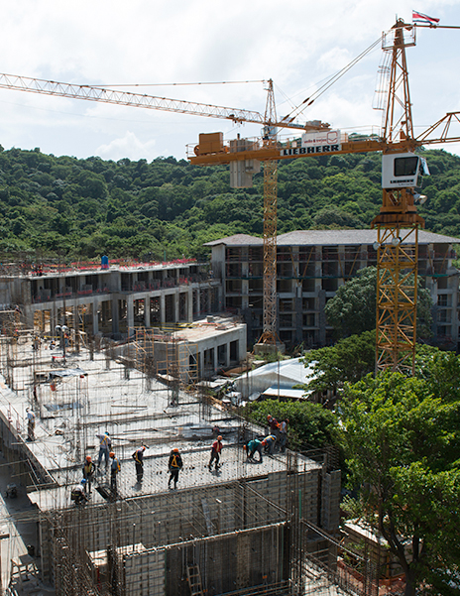

Constructora Volio & Trejos is a Costa Rican company that provides construction services, building hotels, industries, shopping centers, offices, and houses since 1983. They strive to create the best experience for their clients by working with strategy, method, discipline, rigor, passion, and commitment. They use cutting-edge technology tools for communication, cost control, and project scheduling. They apply a BIM methodology for cost estimation, constructability analysis, deadline optimization, and collaborative communication among project participants. Their principles are based on sustainability, commitment, passion, control, and communication.

Challenges

To stimulate the potential of its employees towards continuous improvement and innovation of internal procedures, Volio & Trejos acquired the Laserfiche system in 2014. This system aims to transform the organization's culture towards the digitization of its internal processes and centralize digital information for daily consultation and management. Since the implementation of this system, over 531,000 documents have been registered in the Document Manager, and six automated processes have been put into production, ranging from supplier registration to internal processes for employee entry and management. Some of these processes include supplier inclusion, employee entry, training registration, disability, contracts, and purchase orders. Previously, the supplier inclusion process was entirely manual, with collaborators filling out printed forms and depositing them in physical files.

Solution

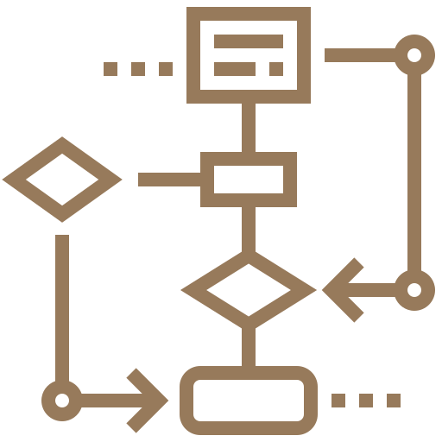
The IT supervisor of Volio & Trejos, Luis Brenes, responsible for the project, explained that the company mapped out the entire process to identify bottlenecks and designed a new flow, considering different possible scenarios. "Initially, we identified what the platform could offer according to our needs, and after planning and development, we trained the entire management team and created manuals for staff to understand and become familiar with the system. In just the first six months, the portal already had 11,326 documents entered, and 25 automated processes in progress in the Forms module."

Benefits and results

The complete execution time of the automated supplier management process has been optimized to 10 business days, from application to acceptance.

Beneficios y resultados

The automation of these processes has allowed the organization to know and control its response times to requests and business processes in real-time.

The document manager has enabled proper management of information access and security.

The implementation has benefited the organization by reducing paper usage and expenses, as their automated workflows generate 100% digital processes.

About

Aplicom was founded over 24 years ago with the aim of being a commercial ally in the digital transformation processes of companies. With 100% Costa Rican capital, their value proposition is to empower technology, innovation, and knowledge of organizations, reducing operational expenses and increasing efficiency and productivity in all their processes. In 1998, they decided to work with the renowned American system Laserfiche, with which they have successfully implemented various projects in different sectors and verticals, both in Costa Rica and throughout the region.

Aplicom's Differentiators
• 20 years of experience in Laserfiche implementation.
• 9 consecutive years as Laserfiche Winner Circle, an award given to the best representatives worldwide.
• A team of highly qualified and certified consultants directly by Laserfiche.
• Present in the region implementing projects with Laserfiche: Panama, Chile, Bolivia, Mexico, Puerto Rico, Dominican Republic, Haiti.

